Type: Original Research Article/ Review Article/ Case Study (Remove two types that are not necessary. Clearly state the type of work you do)

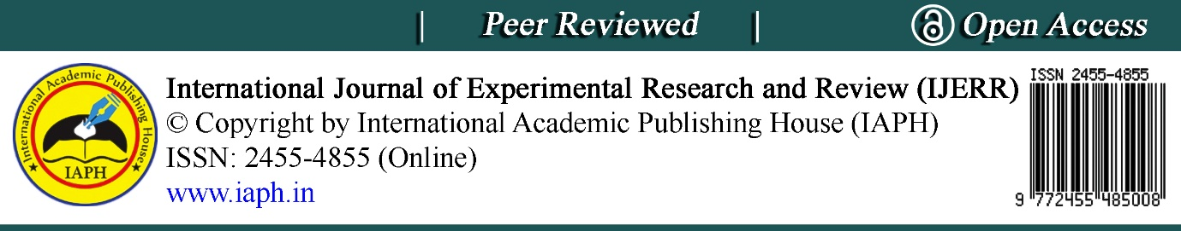

After reading, remove the following information:
# Please provide the title of the work/manuscript, the author's name, affiliation, email address and the ORCID number
# Encourage everyone to provide their full name (1st name, Middle name and Surname/family name), full Affiliation, e-mail address (for all authors) & orcid id (for all authors). The following link should be prepared for those authors who do not have an Orcid id: https://orcid.org/register.

Example:
Luminescent metal-organic frameworks

Sulagna Biswas¹, Debabrata Singha² and Nilasish Pal^{1*}
¹Department of Chemistry, Seth Anandram Jaipuria College, Kolkata-700005, West Bengal, India; ²Department of Chemistry, Visva-Bharati University, Santiniketan, Birbhum-731235, West Bengal, India

E-mail/ Orcid id:
SB, sulagnabiswas9073@gmail.com, https://orcid.org/0000-0003-3898-938X;
DS, singhadebabrata07@gmail.com,https://orcid.org/0000-0001-8958-2016;
NP, nilasishpal@gmail.com, https://orcid.org/0000-0002-7206-5407

*Corresponding Author: nilasishpal@gmail.com

# Full Abstract & Keywords = 12 font, Times New Roman
# Not exceeding 340 words (Standard 250-300 words)
# Keywords:

#Maximum 6 in numbers

#Arrange the items (keywords) alphabetically (Example- Basal media, callus, nodal segment, palmarosa grass, somatic embryogenesis).
#The first letter should be written in all capital letters. Without special words, the letters, in other words, are small.
Example-
Fish market, induced breeding, major carp, pituitary gland, survey.

